**Assignment - 5**

**All of you have to perform the information gathering techniques on below listed domains. For this you have to use nmap, nmap scripts, robots.txt file, dns lookup, Whois, lookup and way back machine**

1. **www.ikea.com**

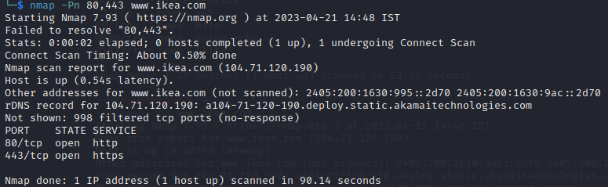

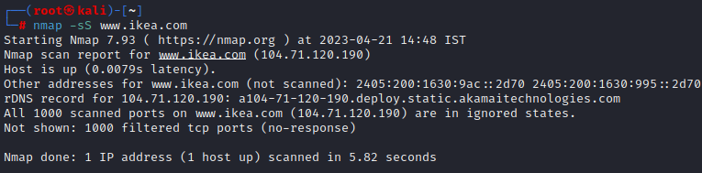

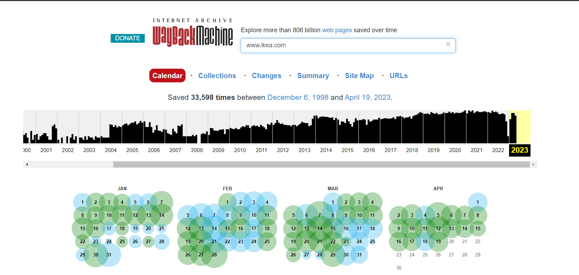

**robots.txt**

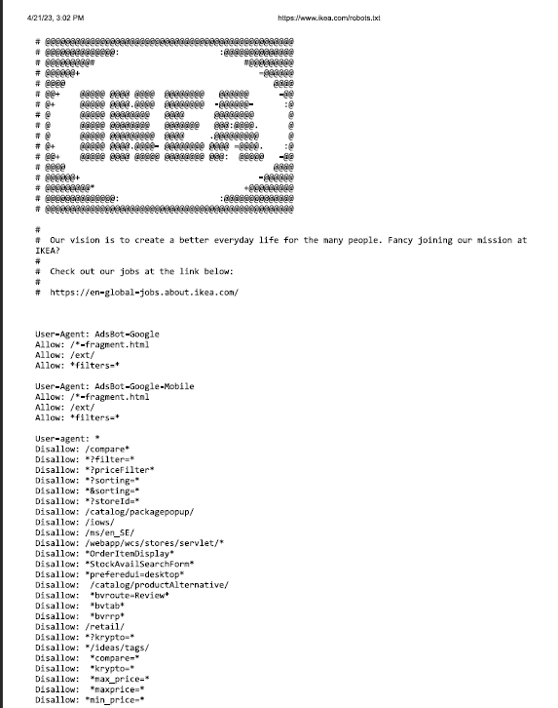

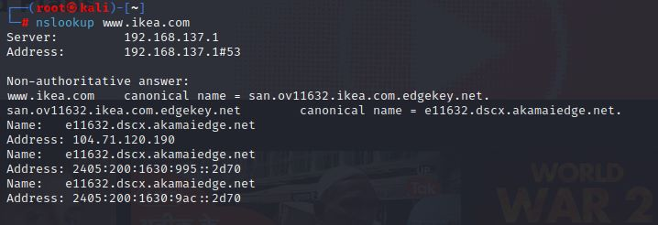

1. **www.safeway.com**

